**Assignment 1: Pseudocode and Flowchart for Sorting Algorithm – Write pseudocode and create a flowchart for a bubble sort algorithm. Provide a brief explanation of how the algorithm works and a simple array of integers to demonstrate a dry run of your algorithm.**

Flowchart:-

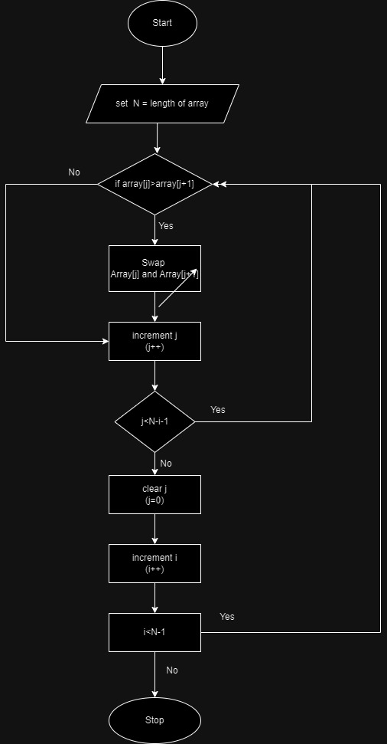

Pseudocode:-

n= length of array

Bubblesort(array , n ){

For I = 0 to n-1 do swapped = false

For j =0 to n-1 {

If array[j] >array[j+1] then swap array[j] and array[j+1]

Swapped = true

If swapped = false then break;

Algorithm Explanation:-

Step 1: check if the first element in array is greater than the next element in the array.

Step 2: if it is greater, swap the element. If is not move to the next element in the array.

Step 3: Repeat step 2 until we reach the end of array.

Step 4: check if the element is sorted . if not , repeat same process from step 1 to step 3 from the last element to first .

Step 5: The final output be sorted array.

**For example: 27, 22 , 55, 33, 11 These are unsorted array.**

First compare 27 with 22, 27 >22 so it will swap as 22 , 27, 55, 33, 11 – it will start with first two element.

Now comparing 27 and 55, 27<55 so, it does not swap.

Compare 55 and 33 , 55 >33 so it swap and make as 22, 27, 33, 55, 11.

Comparing 55 and 11 it will swap and make as 22, 27, 33, 11, 55.

Thus , after one iteration – 22, 27, 33, 11, 55 looks like.

For 2nd iteration , compare 27 and 33 = no swap and 33 and 11 it will swap and looks like

22, 27, 11, 33, 55.

Similarly, 27>11 🡪 it swap – 22, 11, 27, 33, 55.

And after 22>11 🡪 it swap – 11, 22, 27, 33, 55 – sorted array by bubble sorting.